

Objectives

The main goal of the application is to maintain the records of purchase,Sales and stock details with cash transaction maintenance.

Medical Store Management software is very needy for medical Store.

Description

Medical Software management system project used to maintain and track medicine stock inventory detail and store customer and bill detail for medical store.

Flowchart

**START**

**Prescription rejected**

**STOP**

**Exit Transaction**

**Order is served**

Bill is Made

Medicines are issued

**Prescription is checked**

Order is Made

Source Code

#include<stdio.h>

#include<conio.h>

#include<string.h>

#include<ctype.h>

struct Medicine{

int id,price,quantity;

char medicneName[100],Company[100],Mfg_Date[11],Exp_Date[11],info[5000];

}m[100];

void PurchaseMedicine(int number);

void EnterInfoAboutMedicine(int number);

void StockOfMedicine(int number);

void KnowInfoAboutMedicine(int number);

void AddMedicineinStore(int number,struct Medicine m[]);

void DeleteMedicineStore(int number);

void ChangeMedicineDetails(int number);

main()

{

int i,j,choice,number=0,c;

for(i=0;i<100;i++)

{

m[i].id=0;

m[i].price=0;

m[i].quantity=0;

strcpy(m[i].Mfg_Date,"");

strcpy(m[i].Exp_Date,"");

strcpy(m[i].medicneName,"");

strcpy(m[i].Company,"");

strcpy(m[i].info,"");

}

m[0].id=1;

m[0].price=120;

m[0].quantity=30;

strcpy(m[0].Mfg_Date,"23-04-2016");

strcpy(m[0].Exp_Date,"24-04-2020");

strcpy(m[0].medicneName,"Paracetmol");

strcpy(m[0].Company,"ABCD");

strcpy(m[0].info,"Good Medicine for Fever");

do{

printf("Enter\n1 - Purchase Medicine\n2 - Enter Information about a Medicine\n3 - Stock of Medicine in Store\n4 - Medicine Information\n5 - Add Medicine\n6 - Delete a Medicine\n7 - Change Quantity of Medicine\n");

scanf("%d",&choice);

switch(choice)

{

case 1:

{

PurchaseMedicine(number+1);

break;

}

case 2:

{

EnterInfoAboutMedicine(number+1);

break;

}

case 3:

{

StockOfMedicine(number+1);

break;

}

case 4:

{

KnowInfoAboutMedicine(number+1);

break;

}

case 5:

{

++number;

AddMedicineinStore(number,m);

break;

}

case 6:

{

DeleteMedicineStore(number+1);

break;

}

case 7:

{

ChangeMedicineDetails(number+1);

break;

}

}

printf("To Continue with other Options Enter 1 Else any other number\n");

scanf("%d",&c);

}while(c==1);

}

void PurchaseMedicine(int number)

{

int id,check,i,quantity,flag=0;

char name[100];

printf("Enter 1 if you know ID else any other number to enter Name of Medicine\n");

fflush(stdin);

scanf("%d",&check);

if(check==1)

{

printf("Enter Id to purchase Medicine\n");

fflush(stdin);

scanf("%d",&id);

for(i=0;i<number;i++)

{

if(m[i].id==id)

{

flag=1;

int c;

printf("These are the details of Medicine\n");

printf("Name%s\nPrice=%d\nAvailable Quantity=%d\nCompany=%s\nMfg Date=%s\nExp Date=%s\n",m[i].medicneName,m[i].price,m[i].quantity,m[i].Company,m[i].Mfg_Date,m[i].Exp_Date);

if(strcmp(m[i].info,"")==0)

{

printf("Medicine Review/Info=Not Available\n");

}

else

{

printf("Medicine Review/Info=%s\n",m[i].info);

}

printf("Do you want to purchase %s \nIf Yes Enter 1 else any other number\n",m[i].medicneName);

fflush(stdin);

scanf("%d",&c);

if(c==1)

{

printf("Enter Quantity to Purchase\n");

scanf("%d",&quantity);

if(m[i].quantity>quantity)

{

printf("Total Price to be paid=%d\n",quantity*m[i].price);

}

else{

printf("Please Enter quantity below Available Quantity\n");

}

}

break;

}

}

if(flag==0)

{

printf("Entered Id Not Found\n");

}

}

else

{

printf("Enter Name to search and Purchase\n");

fflush(stdin);

gets(name);

for(i=0;i<number;i++)

{

if(strcmp(m[i].medicneName,name)==0)

{

flag=1;

int c;

printf("These are the details of Medicine\n");

printf("Name=%s\nPrice=%d\nAvailable Quantity=%d\nCompany=%s\nMfg Date=%s\nExp Date=%s\n",m[i].medicneName,m[i].price,m[i].quantity,m[i].Company,m[i].Mfg_Date,m[i].Exp_Date);

if(strcmp(m[i].info,"")==0)

{

printf("Medicine Review/Info=Not Available\n");

}

else

{

printf("Medicine Review/Info=%s\n",m[i].info);

}

printf("Do you want to purchase %s \nIf Yes Enter 1 else any other number\n",m[i].medicneName);

fflush(stdin);

scanf("%d",&c);

if(c==1)

{

printf("Enter Quantity to Purchase\n");

scanf("%d",&quantity);

if(m[i].quantity>quantity)

{

printf("Total Price to be paid=%d\n",quantity*m[i].price);

}

else{

printf("Please Enter quantity below Available Quantity\n");

}

}

break;

}

}

if(flag==0)

{

printf("Entered Name Not Found\n");

}

}

}

void EnterInfoAboutMedicine(int number)

{

int i,flag=0,c;

char name[100],info[100];

printf("Enter Name of the medicine you want to Review or include Info\n");

fflush(stdin);

gets(name);

for(i=0;i<number;i++)

{

if(strcmp(m[i].medicneName,name)==0)

{

flag=1;

printf("These are the details of Medicine\n");

printf("Name=%s\nPrice=%d\nAvailable Quantity=%d\nCompany=%s\nMfg Date=%s\nExp Date=%s\n",m[i].medicneName,m[i].price,m[i].quantity,m[i].Company,m[i].Mfg_Date,m[i].Exp_Date);

if(strcmp(m[i].info,"")!=0)

{

printf("Review Already Available!\nIf you want to Add a Review Enter 1 else Any other number\n");

fflush(stdin);

scanf("%d",&c);

}

else

{

printf("Enter review(less than 100 Characters)\n");

fflush(stdin);

gets(m[i].info);

}

if(c==1)

{

printf("Enter review(less than 100 Characters)\n");

fflush(stdin);

gets(info);

strcat(m[i].info,"; ");

strcat(m[i].info,info);

}

}

}

if(flag==0)

{

printf("Entered Name Not Found\n");

}

}

void KnowInfoAboutMedicine(int number){

int i,flag=0;

char name[100];

printf("Enter Name of the medicine you want to see Review and Info\n");

fflush(stdin);

gets(name);

for(i=0;i<number;i++)

{

if(strcmp(m[i].medicneName,name)==0)

{

flag=1;

printf("These are the details of Medicine\n");

printf("Name=%s\nPrice=%d\nAvailable Quantity=%d\nCompany=%s\nMfg Date=%s\nExp Date=%s\n",m[i].medicneName,m[i].price,m[i].quantity,m[i].Company,m[i].Mfg_Date,m[i].Exp_Date);

if(strcmp(m[i].info,"")!=0)

{

printf("Review or Info=%s\n",m[i].info);

}

else

{

printf("Review or Info=Not Available\n");

}

}

}

if(flag==0)

{

printf("Entered Name Not Found\n");

}

}

void StockOfMedicine(int number){

int i;

if(number!=0)

{

printf("All Available Items are\n");

for(i=0;i<number;i++)

{

if(m[i].id!=0){

printf("Id=%d\nName=%s\t\tPrice=%d\tAvailable Quantity=%d\nCompany=%s\t\tMfg Date=%s\tExp Date=%s\n",m[i].id,m[i].medicneName,m[i].price,m[i].quantity,m[i].Company,m[i].Mfg_Date,m[i].Exp_Date);

if(strcmp(m[i].info,"")!=0)

{

printf("Review or Info=%s\n",m[i].info);

}

else

{

printf("Review or Info=Not Available\n");

}

}

}

}

else{

printf("No Items or Medicines Available\n");

}

}

void AddMedicineinStore(int number,struct Medicine m[])

{

char name[100];

printf("Enter Medicine Id\n");

scanf("%d",&(m[number].id));

fflush(stdin);

printf("Enter Medicine Name\n");

fflush(stdin);

gets(name);

strcpy(m[number].medicneName,name);

printf("Enter Company Name\n");

fflush(stdin);

gets(m[number].Company);

printf("Enter Manufactured Date\n");

fflush(stdin);

gets(m[number].Mfg_Date);

printf("Enter Expiry Date\n");

fflush(stdin);

gets(m[number].Exp_Date);

printf("Enter Quantity\n");

fflush(stdin);

scanf("%d",&(m[number].quantity));

printf("Enter Price\n");

fflush(stdin);

scanf("%d",&(m[number].price));

strcpy(m[number].info,"");

printf("Medicine with id %d Added Successfully\n",m[number].id);

}

void DeleteMedicineStore(int number)

{

int id,i,flag=0,num;

printf("Enter Id to be deleted\n");

fflush(stdin);

scanf("%d",&id);

for(i=0;i<number;i++)

{

if(m[i].id==id)

{

flag=1;

m[i].id=0;

m[i].price=0;

m[i].quantity=0;

strcpy(m[i].medicneName,"");

strcpy(m[i].Company,"");

strcpy(m[i].Mfg_Date,"");

strcpy(m[i].Exp_Date,"");

strcpy(m[i].info,"");

num=i;

break;

}

}

if(flag==1)

{

printf("Medicine with %d is Deleted Successfully\n",id);

}

}

void ChangeMedicineDetails(int number)

{

int id,quantity,choice,c,i;

printf("Enter id to change Details\n");

scanf("%d",&id);

for(i=0;i<number;i++)

{

if(m[i].id==id && m[i].id!=0)

{

do

{

printf("Enter\n1 - Change Quantity\n2 - Change Price\n3 - Change Name\n4 - Change Company\n5 - Change Manufaturing Date\n6 - Change Expiry Date\n7 - Change Info\nAny other number to exit");

scanf("%d",&choice);

if(choice==1)

{

int quantity;

printf("Enter Quantity to be changed\n");

fflush(stdin);

scanf("%d",&quantity);

m[i].quantity=quantity;

printf("Quantity changed Successfully\n");

}

if(choice==2)

{

int price;

printf("Enter Price to be changed\n");

fflush(stdin);

scanf("%d",&price);

m[i].price=price;

printf("Price changed Successfully\n");

}

if(choice==3)

{

char name[100];

printf("Enter Name to be changed\n");

fflush(stdin);

gets(name);

strcpy(m[i].medicneName,name);

printf("Medicine Name changed Successfully\n");

}

if(choice==4)

{

char company[100];

printf("Enter company to be changed\n");

fflush(stdin);

gets(company);

strcpy(m[i].Company,company);

printf("Company changed Successfully\n");

}

if(choice==5)

{

char mfg[11];

printf("Enter Manufacturing date to be changed\n");

fflush(stdin);

gets(mfg);

strcpy(m[i].Mfg_Date,mfg);

printf("Manufacturing Date changed Successfully\n");

}

if(choice==6)

{

char exp[11];

printf("Enter Expiry date to be changed\n");

fflush(stdin);

gets(exp);

strcpy(m[i].Exp_Date,exp);

printf("Expiry Date changed Successfully\n");

}

if(choice==7)

{

char info[100];

printf("Enter Info to be changed(Less than 100 Characters)\n");

fflush(stdin);

gets(info);

strcpy(m[i].info,info);

printf("Info changed Successfully\n");

}

if(choice<=0 && choice>7)

{

printf("Enter valid Choice\n");

}

printf("Enter 1 to Change other Details Else any other number\n");

fflush(stdin);

scanf("%d",&c);

}while(c==1);

break;

}

}

}

Outputs

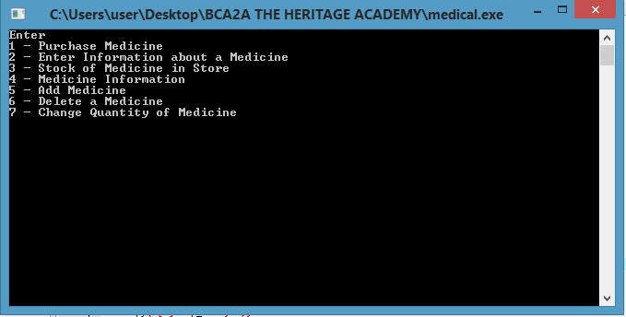Add medicine

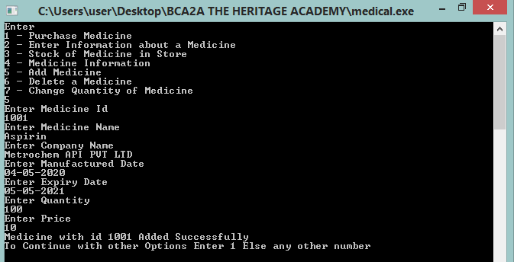

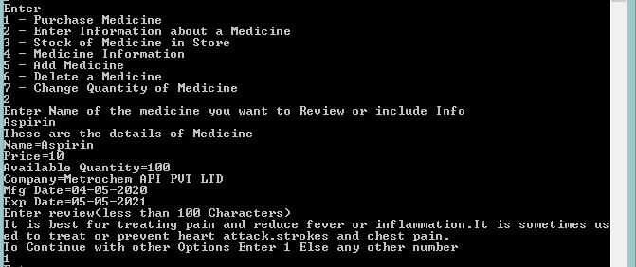Enter information about a medicine

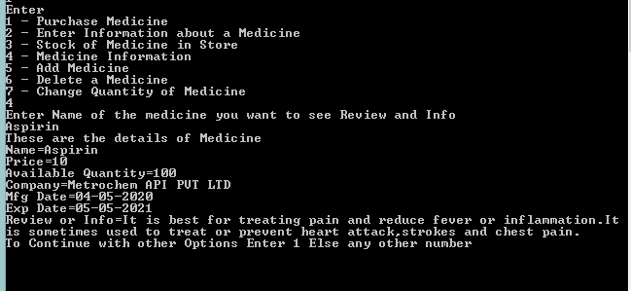Medicine information

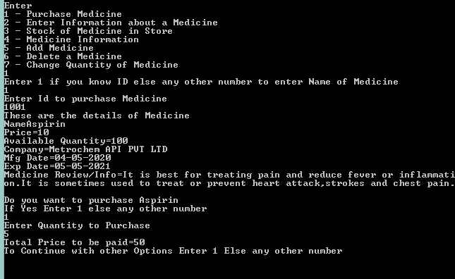Purchase medicine

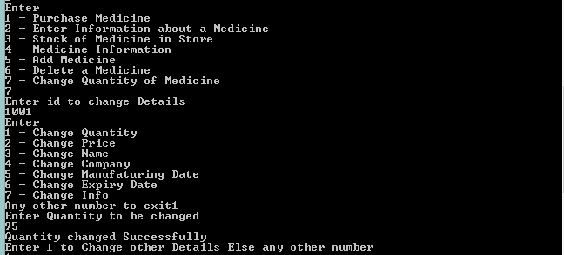Change quantity of medicine

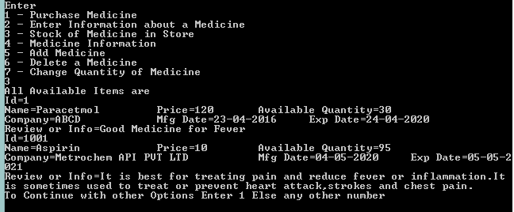Stock of medicine in store

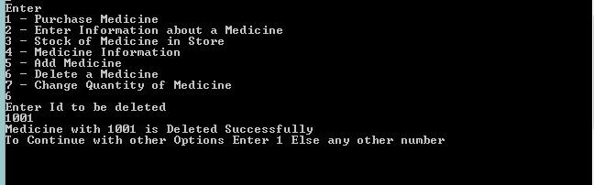Delete a medicine

* Anand Raj Keshari
* Anisha Chatterjee
* Dikshya Shaw
* Dwipannita Sen